Truncated Square Pyramid

Definition
# Source: AI Source: Provided by: [Data Path: Persons Table -> ID Column: 1, Name_En Column: Motasem Essam] -> From: [ChatGPT] on [7/25/2026]
A Truncated Square Pyramid is a solid formed by cutting off the apex of a square pyramid with a plane parallel to its square base.
The resulting solid is called a Square Pyramid Frustum or Frustum of a Square Pyramid.
It has two parallel square bases of different sizes, connected by four trapezoidal lateral faces.
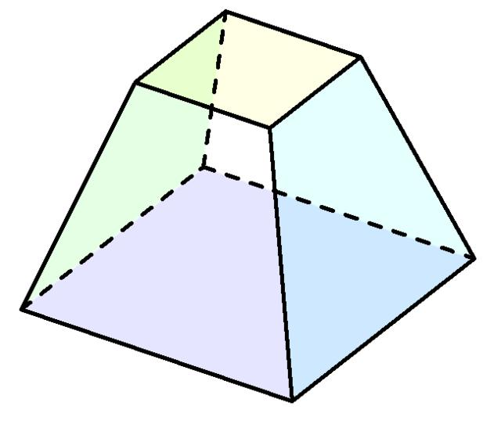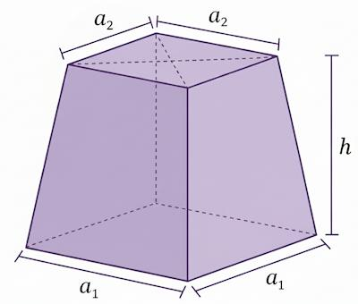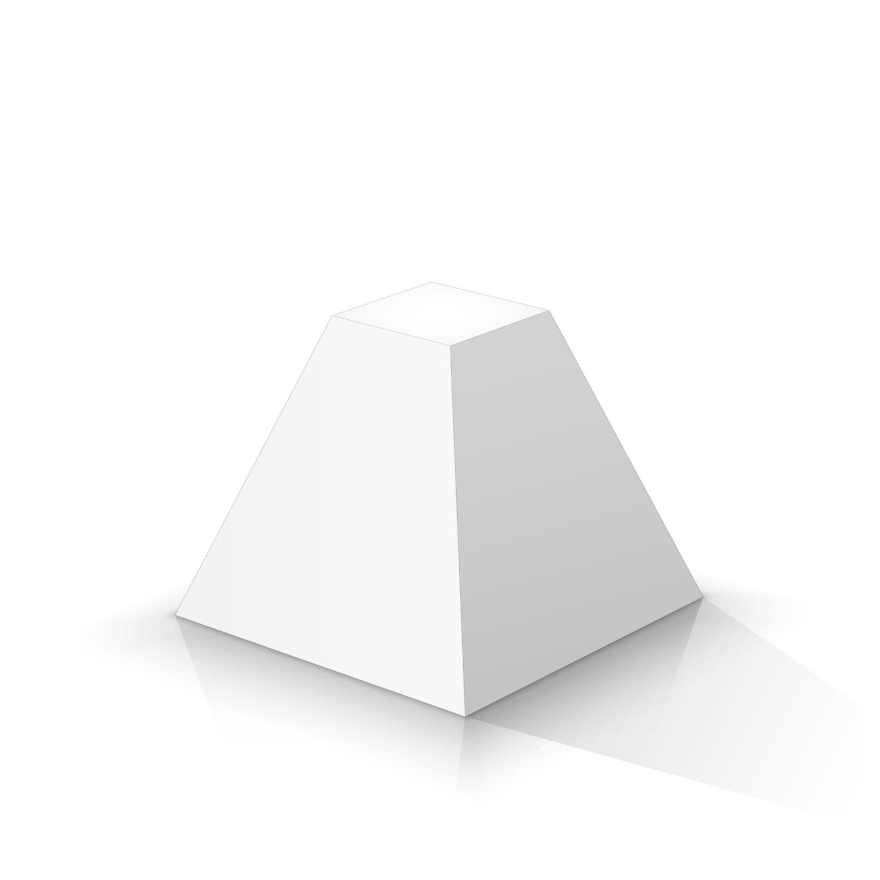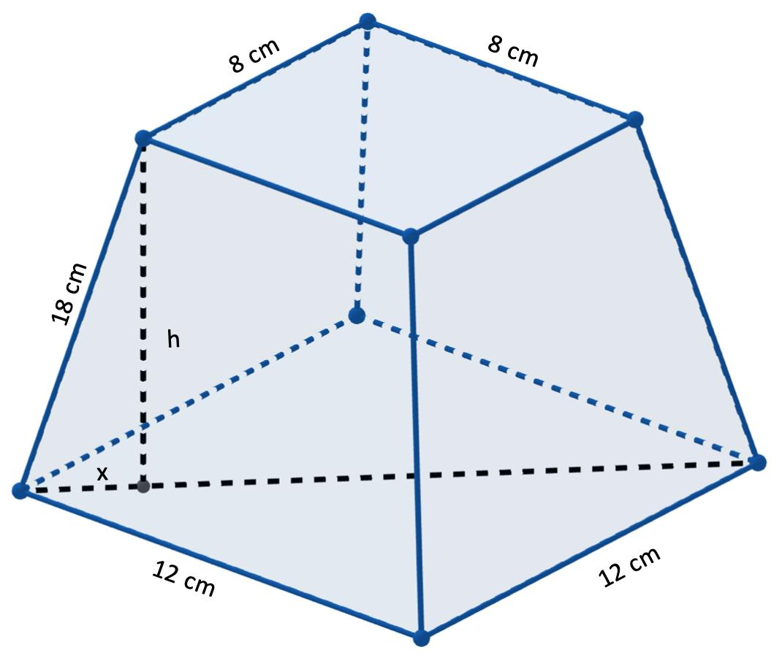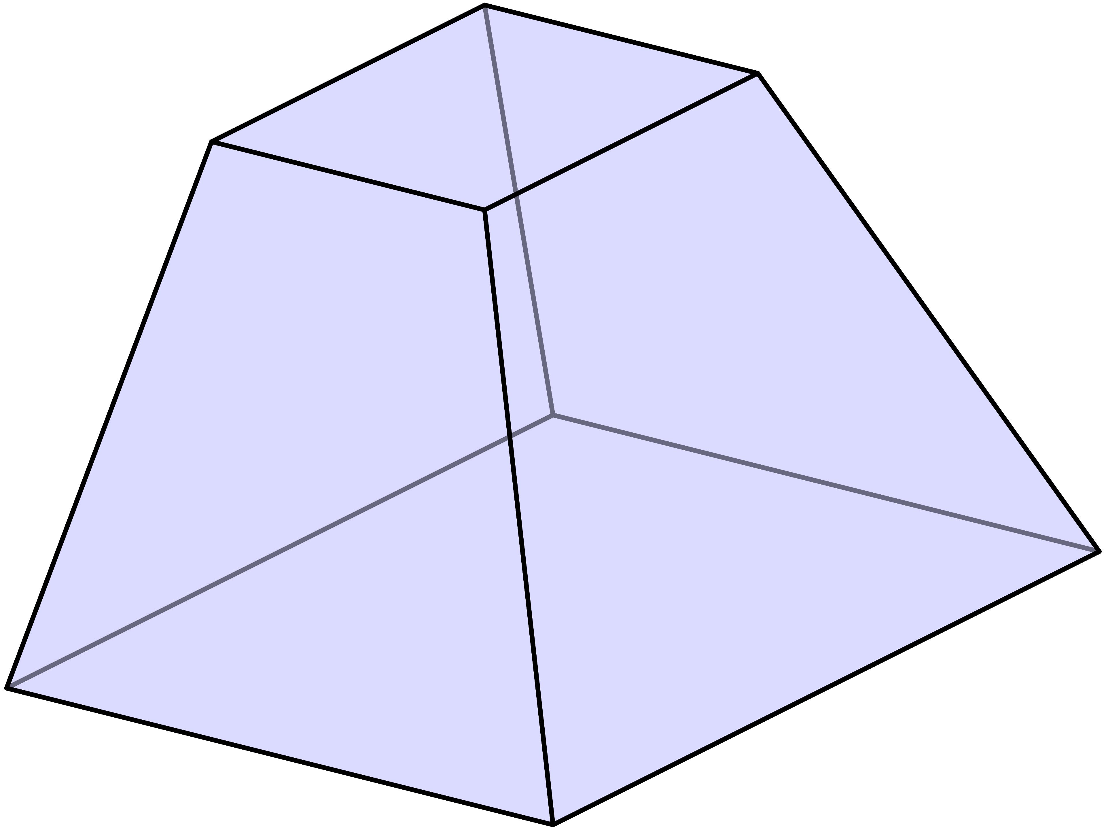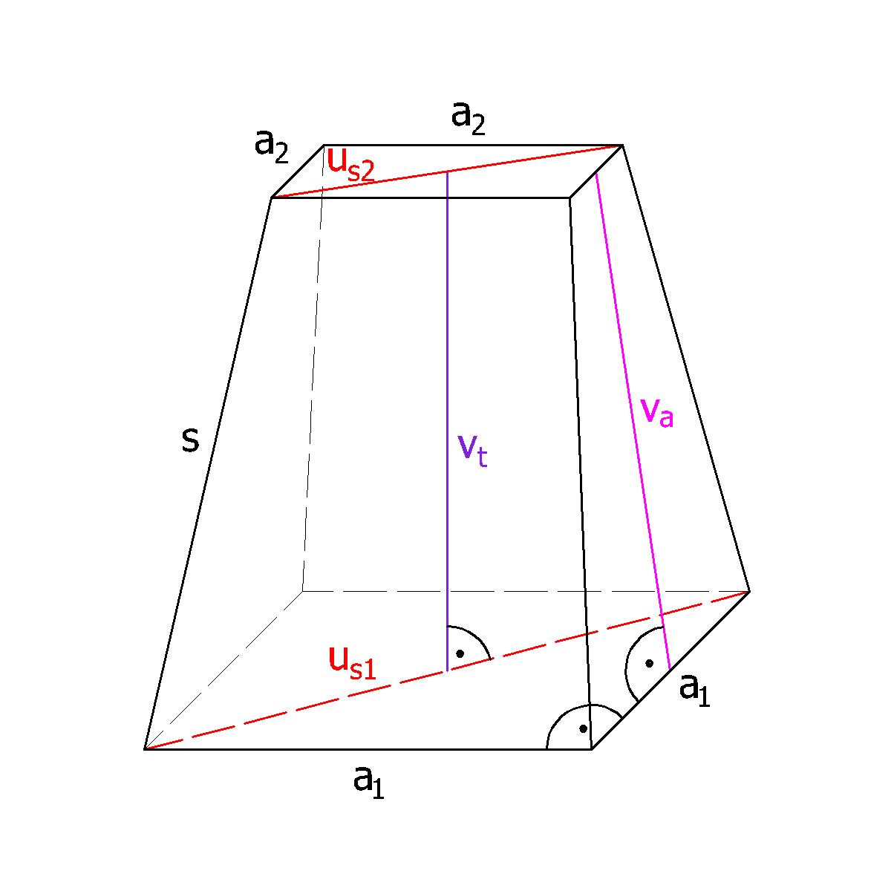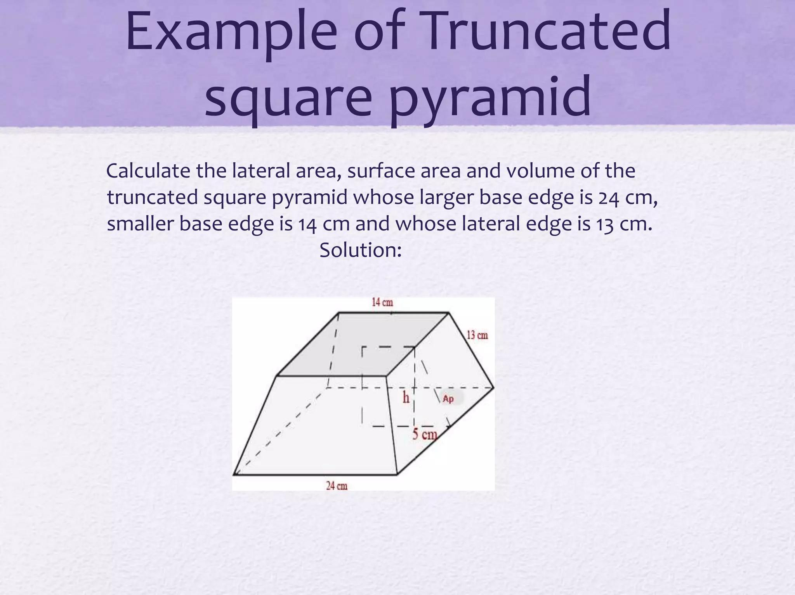

Geometric Structure
# Source: AI Source: Provided by: [Data Path: Persons Table -> ID Column: 1, Name_En Column: Motasem Essam] -> From: [ChatGPT] on [7/25/2026]
An original square pyramid consists of:
- 1 Square Base: The bottom face.
- 4 Triangular Lateral Faces: Meeting at the apex.
- 5 Vertices: Four base vertices and one apex.
- 8 Edges: Four base edges and four lateral edges.
After truncation:
- The original square base remains unchanged.
- A smaller square face is created by the cutting plane.
- The four original triangular lateral faces become trapezoidal faces.
- The original apex is removed.

Face Composition
# Source: AI Source: Provided by: [Data Path: Persons Table -> ID Column: 1, Name_En Column: Motasem Essam] -> From: [ChatGPT] on [7/25/2026]
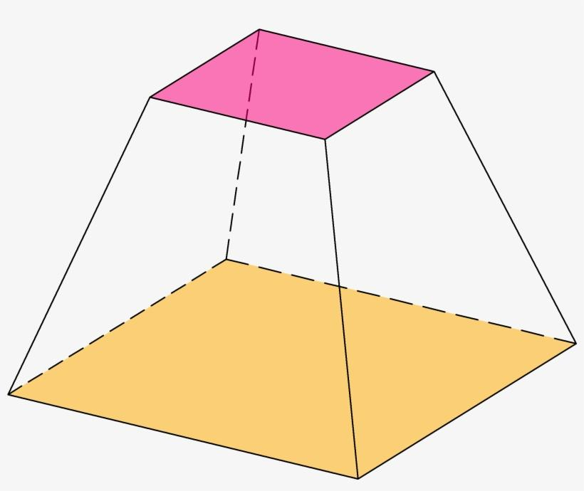

Large Square Base
# Source: AI Source: Provided by: [Data Path: Persons Table -> ID Column: 1, Name_En Column: Motasem Essam] -> From: [ChatGPT] on [7/25/2026]
The original base of the square pyramid.

Small Square Base
# Source: AI Source: Provided by: [Data Path: Persons Table -> ID Column: 1, Name_En Column: Motasem Essam] -> From: [ChatGPT] on [7/25/2026]
The new face created by cutting off the apex with a plane parallel to the original base.
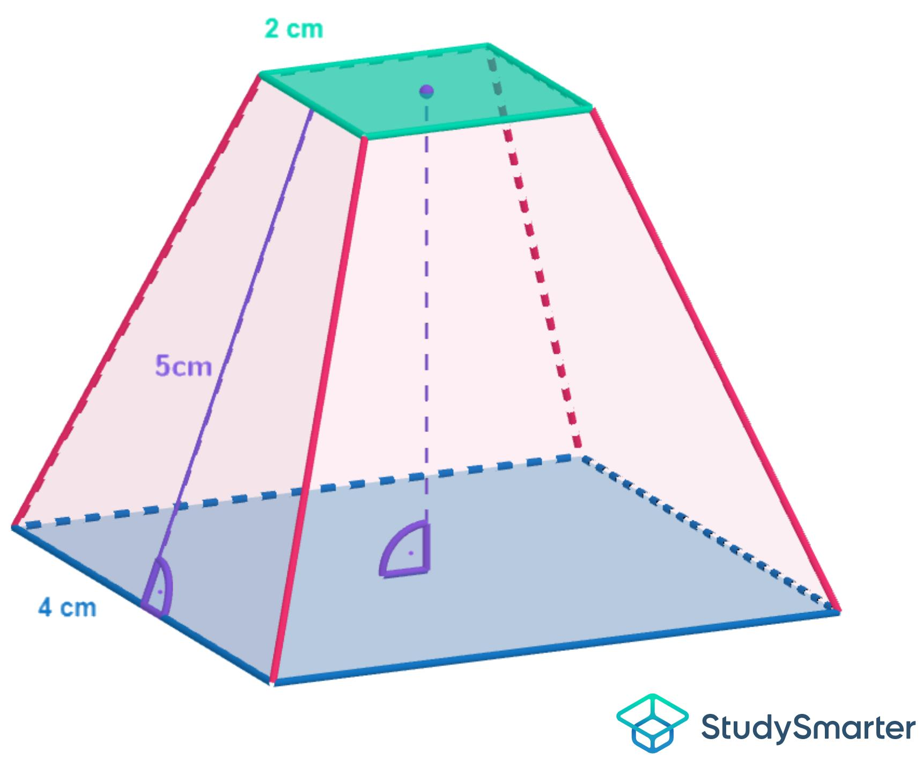

Trapezoidal Lateral Faces
# Source: AI Source: Provided by: [Data Path: Persons Table -> ID Column: 1, Name_En Column: Motasem Essam] -> From: [ChatGPT] on [7/25/2026]
The remaining portions of the original triangular lateral faces.
Total face composition:
- 2 Square Faces.
- 4 Trapezoidal Faces.
- 6 Faces in total.

Mathematical Properties
# Source: AI Source: Provided by: [Data Path: Persons Table -> ID Column: 1, Name_En Column: Motasem Essam] -> From: [ChatGPT] on [7/25/2026]
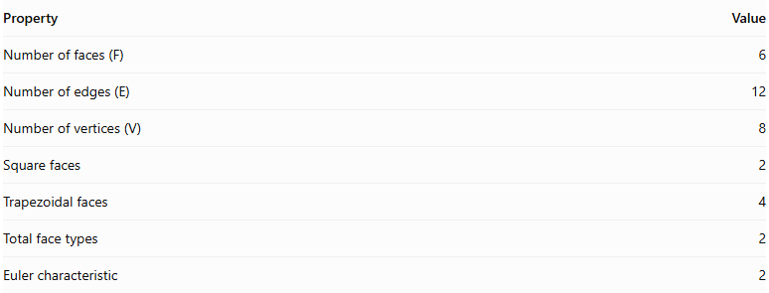
Property | Value
Number of faces (F) | 6
Number of edges (E) | 12
Number of vertices (V) | 8
Square faces | 2
Trapezoidal faces | 4
Total face types | 2
Euler characteristic | 2
Euler's Formula
$$V-E+F=2$$
$$8-12+6=2$$
Volume Formula
The volume of a square pyramid frustum is:
$$V=\frac{h}{3}(A_{1}+A_{2}+\sqrt{A_{1}A_{2}})$$
Where:
- $h$ = perpendicular distance between the two square bases.
- $A_{1}$ = area of the larger square base.
- $A_{2}$ = area of the smaller square base.
If the side lengths of the two square bases are $a$ and $b$:
$$V=\frac{h}{3}(a^{2}+ab+b^{2})$$

Constructing Truncated Square Pyramid in Solid Geometry

Instruments Used
# Source: AI Source: Provided by: [Data Path: Persons Table -> ID Column: 1, Name_En Column: Motasem Essam] -> From: [ChatGPT] on [7/25/2026]
The construction uses physical geometric drawing instruments rather than coordinate-based methods.
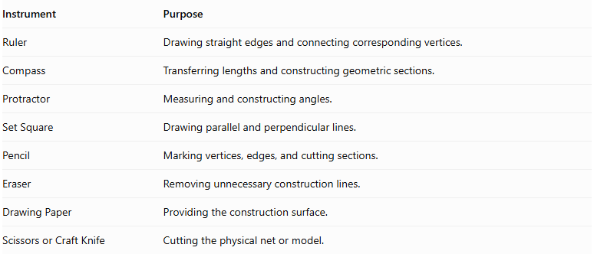
Instrument | Purpose
Ruler | Drawing straight edges and connecting corresponding vertices.
Compass | Transferring lengths and constructing geometric sections.
Protractor | Measuring and constructing angles.
Set Square | Drawing parallel and perpendicular lines.
Pencil | Marking vertices, edges, and cutting sections.
Eraser | Removing unnecessary construction lines.
Drawing Paper | Providing the construction surface.
Scissors or Craft Knife | Cutting the physical net or model.

Construction Procedures

Original-Pyramid-Based Construction
# Source: AI Source: Provided by: [Data Path: Persons Table -> ID Column: 1, Name_En Column: Motasem Essam] -> From: [ChatGPT] on [7/25/2026]
- Draw a square pyramid using a ruler and other geometric instruments.
- Identify its four base vertices and apex.
- Mark four points on the lateral edges at corresponding proportional positions.
- Connect these points to form a square section parallel to the original base.
- Remove or omit the upper portion of the pyramid.
- Complete the four trapezoidal lateral faces.
- Darken the visible edges and use dashed lines for hidden edges.

Base-Based Construction
# Source: AI Source: Provided by: [Data Path: Persons Table -> ID Column: 1, Name_En Column: Motasem Essam] -> From: [ChatGPT] on [7/25/2026]
- Draw the larger square base.
- Construct a smaller similar square base parallel to it.
- Position the smaller base above the larger base.
- Connect corresponding vertices of both squares.
- Complete the four lateral trapezoidal faces.
- Check that the upper and lower bases are parallel and similar.

Vertex-Connection Construction
# Source: AI Source: Provided by: [Data Path: Persons Table -> ID Column: 1, Name_En Column: Motasem Essam] -> From: [ChatGPT] on [7/25/2026]
- Mark the four vertices of the lower square base.
- Mark the four vertices of the upper square base.
- Connect corresponding lower and upper vertices.
- Connect consecutive vertices of each base.
- Verify that the solid has eight vertices and twelve edges.

Edge-Based Construction
# Source: AI Source: Provided by: [Data Path: Persons Table -> ID Column: 1, Name_En Column: Motasem Essam] -> From: [ChatGPT] on [7/25/2026]
- Draw the four edges of the lower square base.
- Draw the four edges of the upper square base.
- Construct the four lateral edges connecting corresponding vertices.
- Complete the four trapezoidal lateral faces.

Face-Based Construction
# Source: AI Source: Provided by: [Data Path: Persons Table -> ID Column: 1, Name_En Column: Motasem Essam] -> From: [ChatGPT] on [7/25/2026]
- Construct the lower square base.
- Construct the upper square base parallel to it.
- Draw four trapezoidal lateral faces between the bases.
- Connect all corresponding edges.
- Ensure that the six faces form a closed solid.

Net-Based Construction
# Source: AI Source: Provided by: [Data Path: Persons Table -> ID Column: 1, Name_En Column: Motasem Essam] -> From: [ChatGPT] on [7/25/2026]
- Draw one larger square base.
- Draw one smaller similar square base.
- Construct four trapezoidal lateral faces around the bases.
- Add tabs if necessary for physical assembly.
- Cut out the net.
- Fold the trapezoidal faces and join their corresponding edges to form the truncated square pyramid.
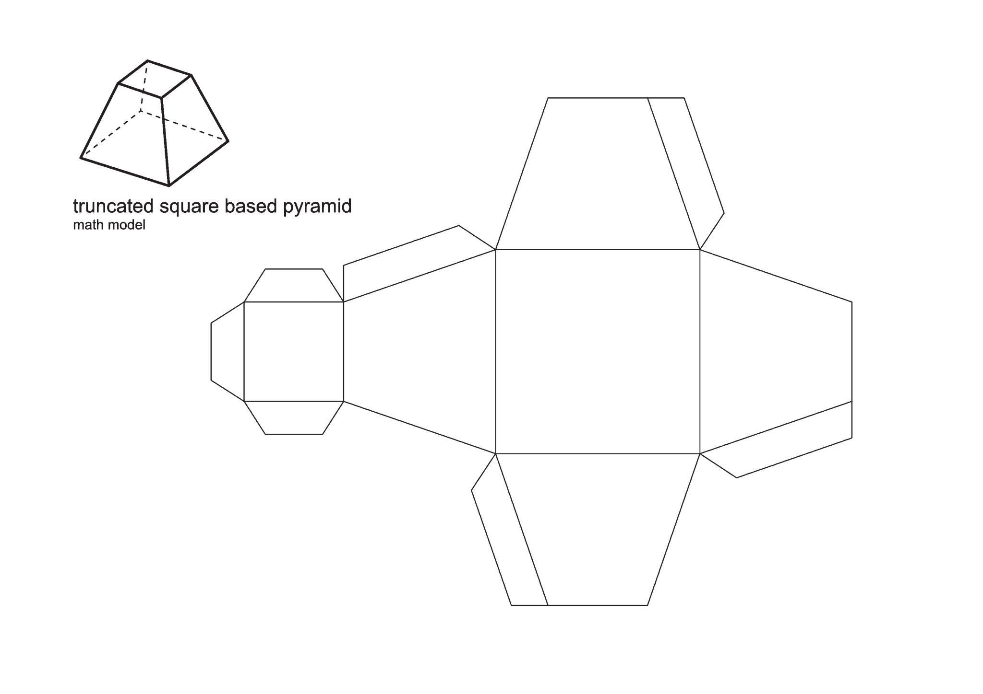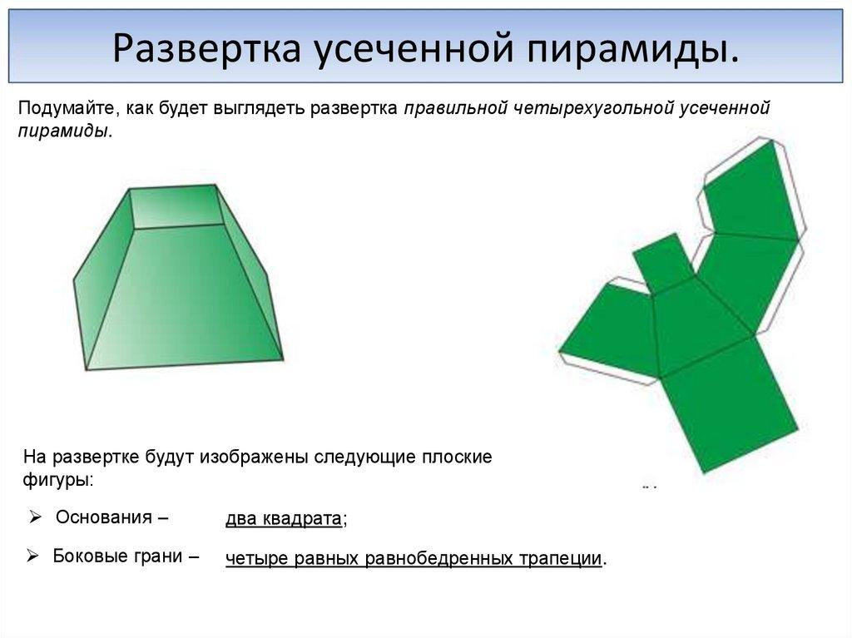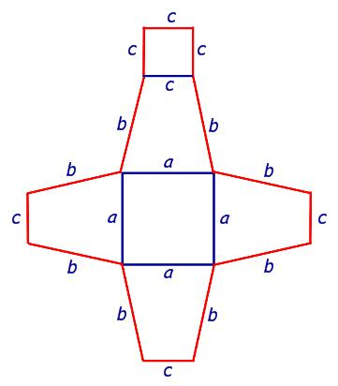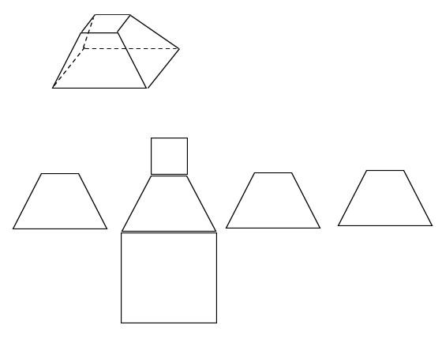

Key Points
# Source: AI Source: Provided by: [Data Path: Persons Table -> ID Column: 1, Name_En Column: Motasem Essam] -> From: [ChatGPT] on [7/25/2026]
- It originates from a square pyramid.
- It is formed by removing the apex using a plane parallel to the base.
- It has two parallel square bases of different sizes.
- It has four trapezoidal lateral faces.
- It contains 6 faces, 12 edges, and 8 vertices.
- It is classified as a square pyramid frustum.
- Its volume depends on the height and the areas of its two bases.
Important terminology distinction:
A square pyramid frustum should not be confused with a vertex-truncated square pyramid, in which one or more vertices are cut off without necessarily using a plane parallel to the original base.

Conclusion
# Source: AI Source: Provided by: [Data Path: Persons Table -> ID Column: 1, Name_En Column: Motasem Essam] -> From: [ChatGPT] on [7/25/2026]
The Truncated Square Pyramid is a square pyramid with its apex removed by a plane parallel to its base. It forms a square pyramid frustum consisting of two square bases and four trapezoidal lateral faces, with 6 faces, 12 edges, and 8 vertices.

